Table of contents
Getting started with JavaFX 2
Study this first 2
Real world examples 2
child controllers 2
sometimes need css class of inner component 4
a custom component containing another custom component 4
the accompanying java for the custom component 5
Use of a custom component 5
expression binding 6
binding 6
SimpleObjectProperty 7
setup observing to keep values and GUI in sync 8
custom cellFactory 8
a custom CellValueFactory 9
a ColorPicker as content of a cell 10
A value is incorrect, the value field is styled accordingly. As soon as the typed value becomes correct the “error” style is removed. 10
FXCollections 11
swing integration 11
built-in dialogs 12
FileChooser 12
packaging: javafx-maven-plugin 13
use exec-maven-plugin for running / debugging 13

Getting started with JavaFX
This document points you to excellent reading material by oracle on JavaFX. Furthermore you will find code examples from my own experience with JavaFX in practice.

Study this first
https://docs.oracle.com/javafx/2/ The tracks here are very good, below I mention the ones you should at least read.
https://docs.oracle.com/javafx/2/layout/size_align.htm
https://docs.oracle.com/javafx/2/api/javafx/fxml/doc-files/introduction_to_fxml.html
https://docs.oracle.com/javafx/2/api/javafx/scene/doc-files/cssref.html
https://docs.oracle.com/javafx/2/binding/jfxpub-binding.htm
https://docs.oracle.com/javase/8/javafx/api/javafx/collections/FXCollections.html
https://docs.oracle.com/javase/8/javafx/api/javafx/beans/binding/Bindings.html
Also worth mentioning are http://jfxtras.org/ and http://fxexperience.com/controlsfx/

Real world examples
Below examples are taken from https://github.com/eduarddrenth/iText-GUI/tree/workshopsolution
Running:
mvn verify jfx:jar exec:exec
then you may want to import the file src/test/resources/config/styling.properties.

child controllers
Naming of classes and fxml files is tricky here, stick to the (naming)conventions or expect exceptions that are not easy to understand.

Root element of the fxml file to include, note the controller class

<AnchorPane xmlns:fx="http://javafx.com/fxml" fx:controller="com.vectorprint.vectorprintreportgui.TableViewController">

The include element in the parent fxml file, note the fx:id, the name of the field in the parent controller annotated with @FXML must start with this id and end with “Controller”.

<fx:include source="TableView.fxml" fx:id="tableView" />

The reference to the child controller in the parent controller

@FXML
private TableViewController tableViewController;

The image on the next page shows a part that originates from an fx:include
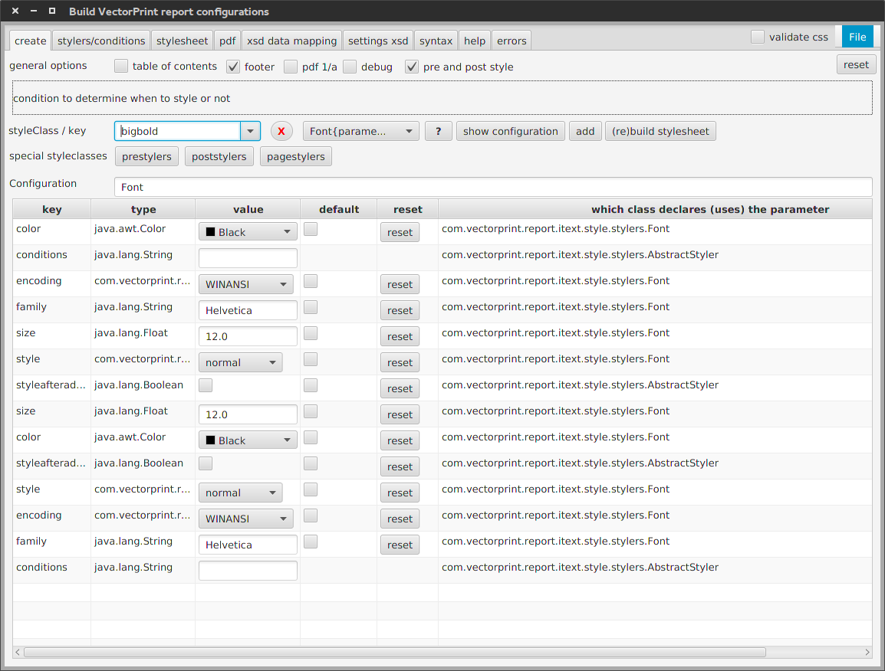

sometimes need css class of inner component
You will need the JavaFX css reference when you develop stylesheets. There you will for example find that a TextArea has an inner “content” that you need when you want to change the background color.

.searching .content {
-fx-background-color: #eeeeee;
}

a custom component containing another custom component
More flexible compared to fx:include, you can create custom components consisting of fxml and accompanying java. You can extend an existing JavaFX Node, add content, add css classes, publish properties, etc. Also custom components can be imported in SceneBuilder, to use in designing. Note that this importing makes a hardcopy of the jar containing your custom components. Note the Anchor properties that pin the bounds of a Node to the bounds of the wrapping AnchorPane. This is a great feature when resizing windows.

<fx:root type="javafx.scene.layout.AnchorPane" xmlns:fx="http://javafx.com/fxml">

<TabPane tabClosingPolicy="UNAVAILABLE" styleClass="xmlareatabs" AnchorPane.topAnchor="12" AnchorPane.bottomAnchor="0" AnchorPane.leftAnchor="0" AnchorPane.rightAnchor="0" >

<Tab text="xml text (searchable)" >
<SearchableTextArea fx:id="searchText" AnchorPane.bottomAnchor="0" AnchorPane.leftAnchor="0" AnchorPane.rightAnchor="0" AnchorPane.topAnchor="0" />
</Tab>

This image show a resized window with everything nicely sized and placed due to Anchors.

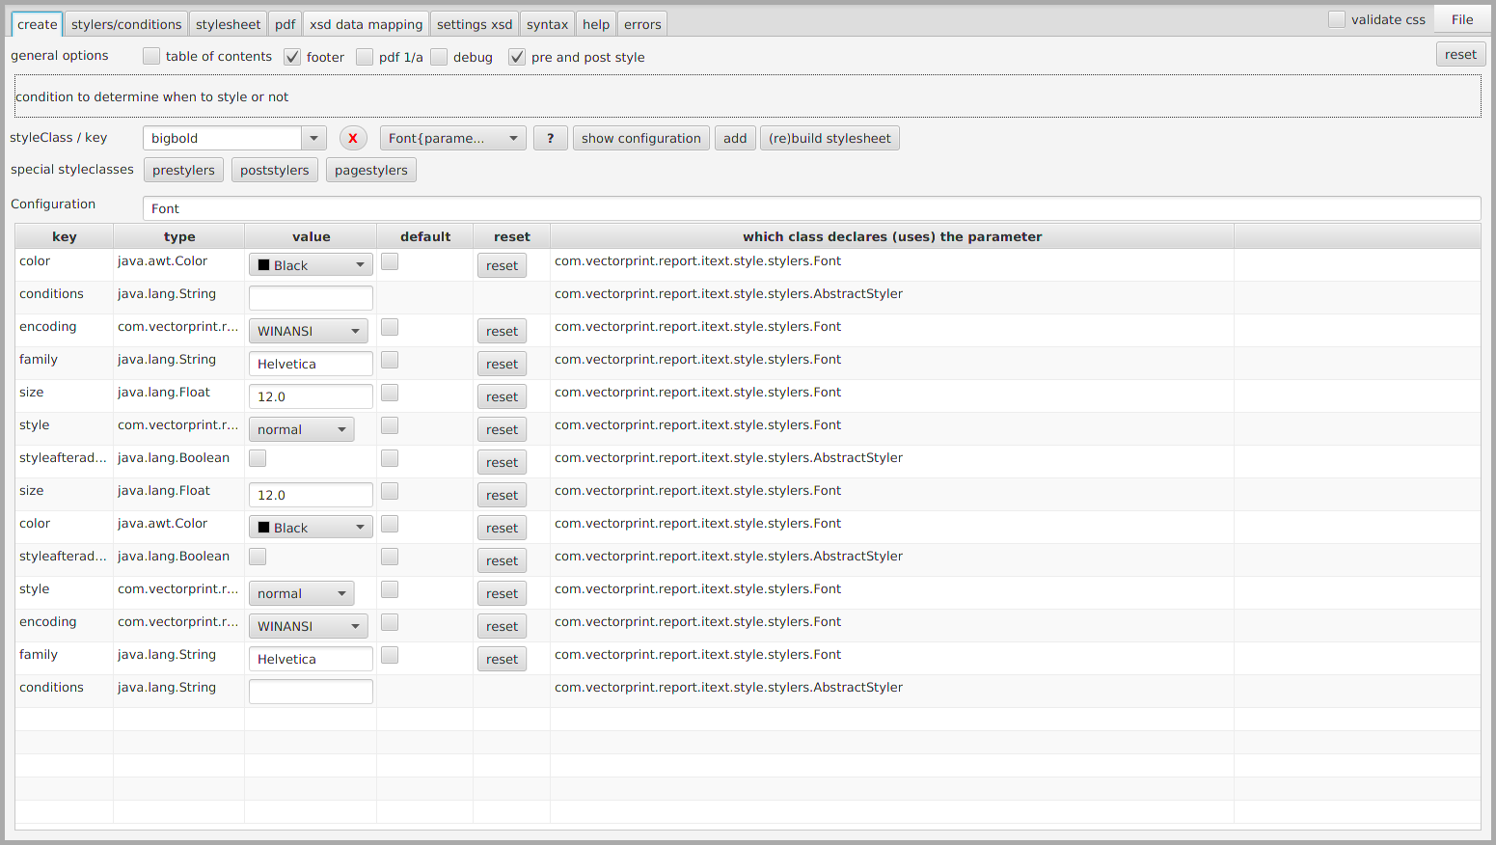

the accompanying java for the custom component
The java for a custom component is pretty straightforward, extend a Node, some obligatory code in the constructor for the wiring part. Furthermore getters and setters you define can directly be used in fxml and will be recognized by SceneBuilder and NetBeans.

public class XmlArea extends AnchorPane {

@FXML
private SearchableTextArea searchText;

@FXML
private TextFlow xmlhighlight;

public XmlArea() {
FXMLLoader fxmlLoader = new FXMLLoader(getClass().getResource(XmlArea.class.getSimpleName() + ".fxml"));
fxmlLoader.setRoot(this);
fxmlLoader.setController(this);

try {
fxmlLoader.load();
} catch (IOException exception) {
throw new RuntimeException(exception);
}
}

Use of a custom component
Self explanatory uses of custom components. Note the use of custom property “editable”.

<SearchableTextArea fx:id="stylesheet" AnchorPane.bottomAnchor="0" AnchorPane.leftAnchor="0" AnchorPane.rightAnchor="0" AnchorPane.topAnchor="56" />

<XmlArea editable="false" fx:id="datamappingxsd" AnchorPane.bottomAnchor="5" AnchorPane.leftAnchor="5" AnchorPane.rightAnchor="5" AnchorPane.topAnchor="60"/>

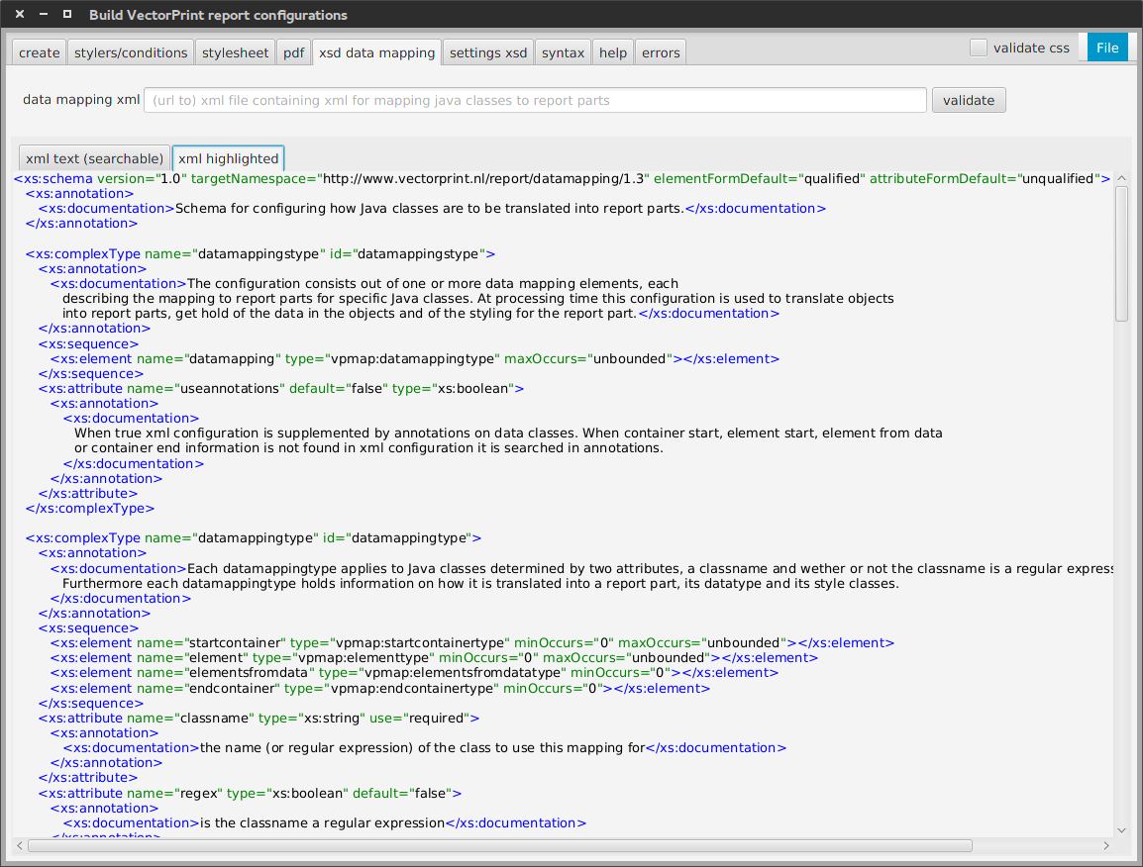
Below you see images of the XmlArea component. It contains two tabs, one with highlighted xml, the other with the same xml, searchable and optionally editable. The searchable xml is a custom component itself.
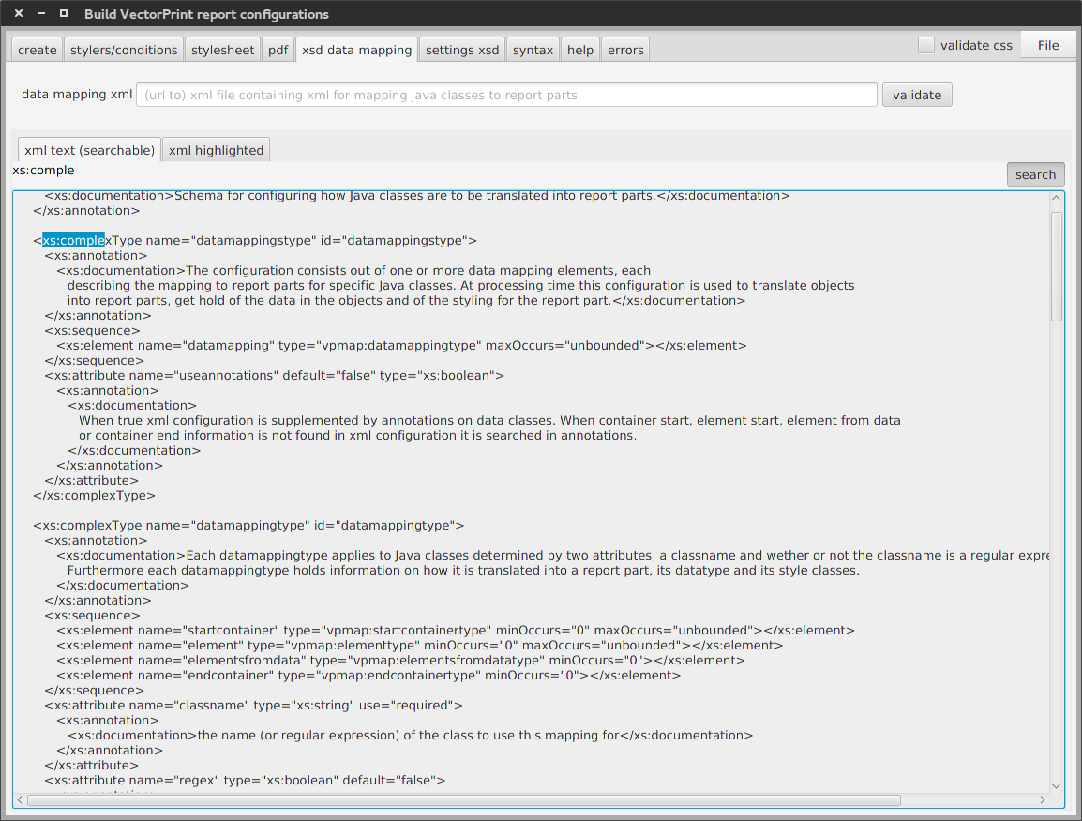
Search functionality of the custom component in action, grayed out, readonly text, highlighted match, showing green search text.

expression binding
You can use expressions in fxml to determine values of properties. Note this is a binding! When the width of the parameterizableTable changes the column width changes along. Note do not add a space before or after the “${“ or “}”, you will get a weird exception.
<TableColumn fx:id="sUpDown" text="upDown" sortable="false"
prefWidth="${parameterizableTable.width * 0.2}" />

binding
One of the neat possibilities of binding is that you can use SimpleObjectProperty to wrap your own objects and make them bindable. All you need to do is call #set() at the leading side (you cannot call #set() on a bound property) and the bound properties will be updated. Note that the binding features in JavaFX is just Java, you can use it in any Java solution, the same holds for other features.

private final ObjectProperty<Parameterizable> currentParameterizable = new SimpleObjectProperty<>();

tableViewController.getCurrentParameterizable().bind(currentParameterizable);

An example of bidirectional binding

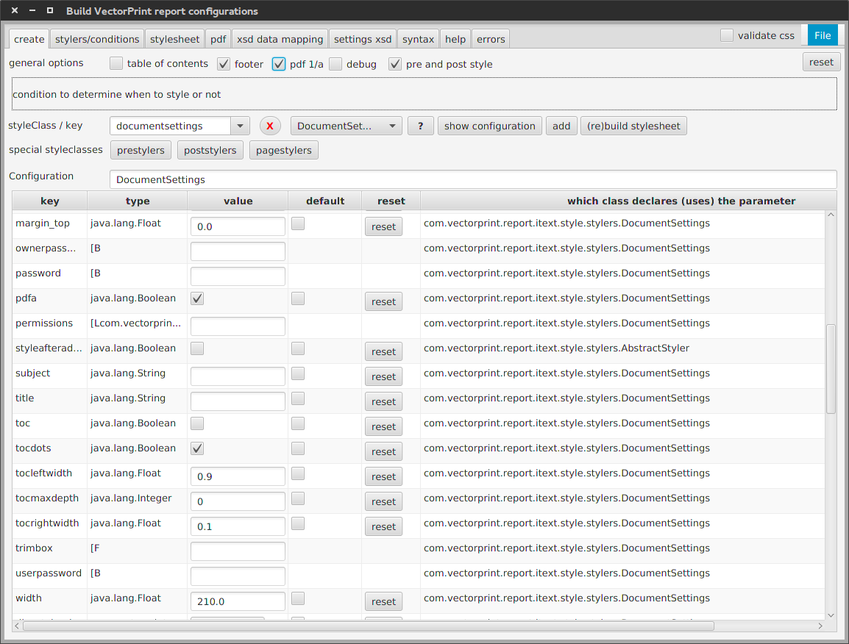

SimpleObjectProperty
SimpleObjectProperty allows you to propagate changes to you own observable objects using the standard binding mechanism JavaFX offers and vise-versa. The example here stresses possibilities to the limit. We have an own own object that is Observable, we have a wrapper for this object that is an Observer and also extends SimpleObjectProperty. Changes to the wrapped object will be notified to the wrapper which can in turn notify the GUI. Furthermore user changes to properties (from the GUI) will be propagated to the wrapper which will then update the value of the wrapped object.

/**
* This class is a SimpleObjectProperty so GUI nodes can be auto updated, it is an Observer so that when the
* encapsulated {@link Parameter} changes this class is notified and can update its value, it is a ChangeListener so
* when GUI nodes change this class is notified and can update its encapsulated Parameter value.
*
* @author Eduard Drenth at VectorPrint.nl
*/
public class ParameterProps<T extends Serializable> extends SimpleObjectProperty<ParameterProps<T>> implements Comparable<ParameterProps>, ChangeListener, Observer {

@Override
public void changed(ObservableValue observable, Object oldValue, Object newValue) {

@Override
public void update(Observable o, Object arg) {
value = …..
fireValueChangedEvent();
}
In the below image the value cell will be updated through binding when the reset button is clicked. Also cells with small GUI Nodes will reflect the correct reset value.

setup observing to keep values and GUI in sync
In order to make the mechanism described above work you need to register the wrapper as observer and as value in the SimpleObjectProperty super class.

public ParameterProps(Parameter<T> p) {
this.p = p;
p.addObserver(this);
set(this);

custom cellFactory
A CellFactory is responsible for drawing contents of a Cell. Note that a Cell here does not necessarily mean table cell. In the factory you return a new Cell whose updateItem method you override that will be called by from a JavaFX graphical thread. In the method you can control the look and feel of the cell (setText, setGraphics,...).

parameterizableCombo.setCellFactory((ListView<Parameterizable> p) -> {
return new ListCell<Parameterizable>() {
@Override
protected void updateItem(Parameterizable t, boolean bln) {
super.updateItem(t, bln);
setText(t == null ? "" : t.getClass().getSimpleName());
setTooltip(t != null ? ViewHelper.tip(help(t)) : null);
}
};
});

a custom CellValueFactory
You can use a CellValueFactory to yield the value of a Cell. This value must be observable, you may achieve this using a JavaFX wrapper class, or better create your own ObservableValue to take full advantage of binding possibilities. In this case the value of the pValue Cell is changed by clicking on a button in another Cell, this change is then propagated to the GUI using fireValueChangedEvent().

pValue.setCellValueFactory(new Callback<TableColumn.CellDataFeatures<ParameterProps, ParameterProps>, ObservableValue<ParameterProps>>() {

@Override
public ObservableValue<ParameterProps> call(TableColumn.CellDataFeatures<ParameterProps, ParameterProps> param) {
return param.getValue();
}

});

a ColorPicker as content of a cell
In this example you see the use of a color picker to set the color value of an item. The item is a ChangeListener that will be notified when a color is picked. Also you see an example where a value is validated on every keystroke showing a red border (or some other error style) until the value is correct. Note the setGraphic(null) which is crucial to wipe out old data in the GUI!

pValue.setCellFactory((TableColumn<ParameterProps, ParameterProps> param) -> {
return new TableCell<ParameterProps, ParameterProps>() {

@Override
protected void updateItem(final ParameterProps item, boolean empty) {
setGraphic(null);
final ColorPicker cp = new ColorPicker();
cp.valueProperty().addListener(item);
setGraphic(cp);
} else {
final TextField textField = new TextField(item.getVal());
textField.textProperty().addListener((ObservableValue<? extends String> observable, String oldValue, String newValue) -> {
textField.getStyleClass().remove("error");
try {
item.setValue(newValue);
} catch (Exception e) {
textField.getStyleClass().add("error");
ViewHelper.writeStackTrace(e, error);
}
});
setGraphic(textField);
}

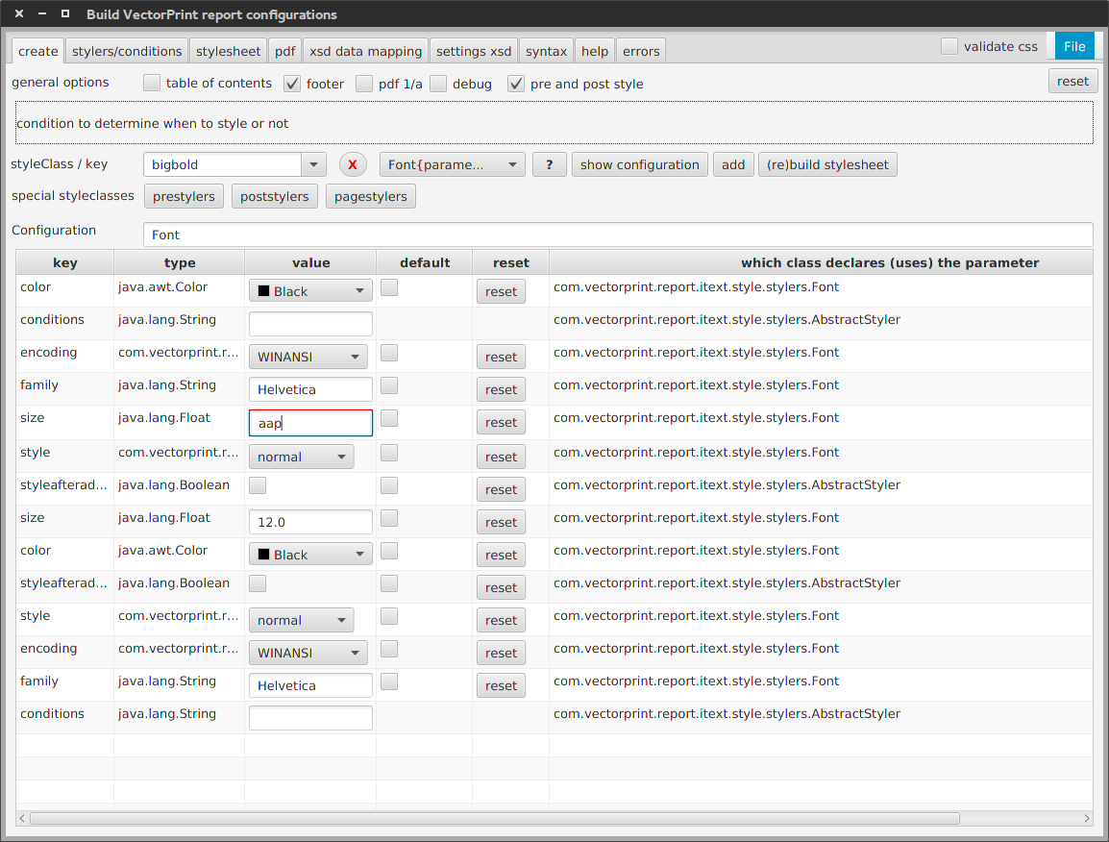
A value is incorrect, the value field is styled accordingly. As soon as the typed value becomes correct the “error” style is removed.

FXCollections
Here a regular list is used for a dropdown, the list is wrapped in an ObservableList for this. Note that changes to the wrapper list are not propagated to the original list nore the other way around.
parameterizableCombo.setItems(FXCollections.observableArrayList(sorted));

swing integration
You can embed a complete swing app in JavaFX and the other way around through JFXPanel. Note that the only relation between container and contained is showing the graphics, events etc. will not be propagated to and from.

<javafx.embed.swing.SwingNode fx:id="pdfpane" AnchorPane.bottomAnchor="0" AnchorPane.leftAnchor="0" AnchorPane.rightAnchor="0" AnchorPane.topAnchor="0" />

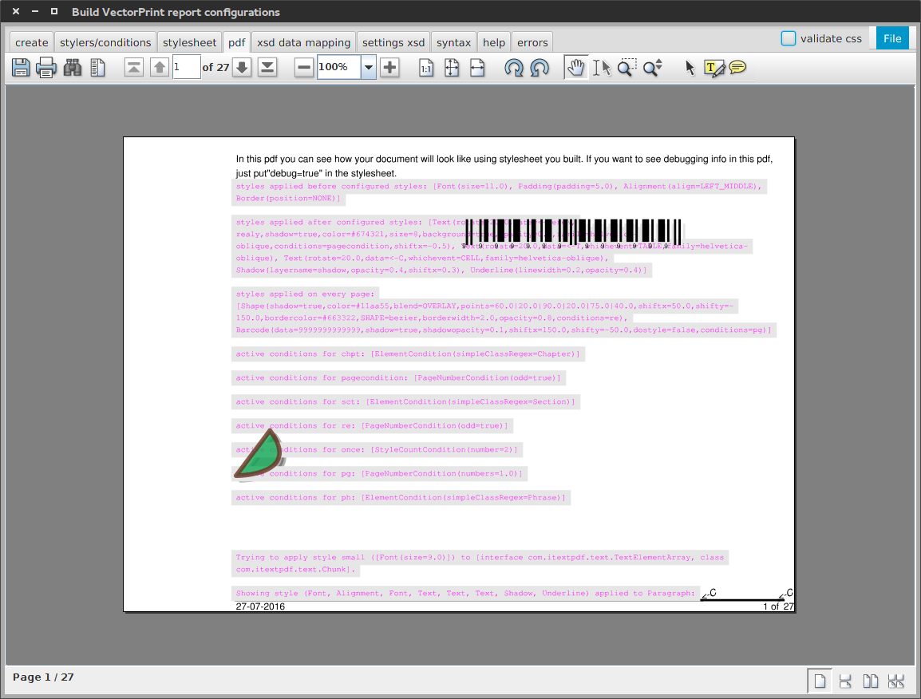

built-in dialogs

Some built-in dialogs are available, easy to use but not very flexible and customizable. Below I had to introduce a wrapper object with a toString method that shows some sensible text in the dropdown. Whereas I would prefer to be able to specify a cellFactory. Also I wanted to use one button and had to call clear() to get rid of the default ones. Last but not least I had to set the headerText to null in order to get closer to the way I wanted the ChoiceDialog to look.

List<ParameterizableWrapper> pw = new ArrayList<>(stylers.size());
stylers.stream().forEach((p) -> {
pw.add(new ParameterizableWrapper(p));
});
Dialog<ParameterizableWrapper> dialog = new ChoiceDialog<>(pw.get(0), pw);
ButtonType bt = new ButtonType("choose", ButtonBar.ButtonData.OK_DONE);
dialog.getDialogPane().getButtonTypes().clear();
dialog.getDialogPane().getButtonTypes().add(bt);
dialog.setTitle("Please choose");
dialog.setHeaderText(null);
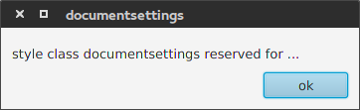
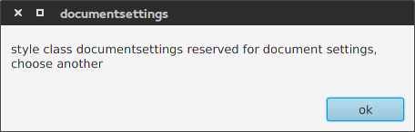
Images of the default dialog, one resized, the other not. Below a not so nice standard choice dialog.
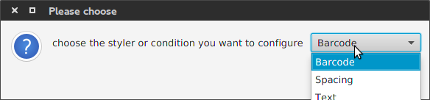
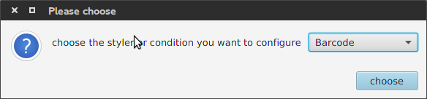

FileChooser

FileChooser fc = new FileChooser();
fc.setTitle("add jar");
FileChooser.ExtensionFilter extensionFilter = new FileChooser.ExtensionFilter("Jar files (*.jar)", "*.jar", "*.JAR", "*.Jar");
fc.getExtensionFilters().add(extensionFilter);
List<File> l = fc.showOpenMultipleDialog(null);

packaging: javafx-maven-plugin
This maven plugin is a wrapper around the options Java has for packaging and deploying Java(FX) apps. See http://docs.oracle.com/javafx/2/deployment/jfxpub-deployment.htm. The good thing being you will be IDE independent and have many options for automation of deployment etc. The bad thing that for running, debugging, profiling and testing from your IDE you will have to do some extra.

You can for example use mvn jfx:jar to create an executable jar in target/jfx/app, or jfx:native to create an executable (installer, .deb, .rpm) in target/jfx/native.

<build>
<plugins>
<plugin>
<groupId>com.zenjava</groupId>
<artifactId>javafx-maven-plugin</artifactId>
<version>8.5.0</version>
<configuration>
<mainClass>${mainClass}</mainClass>
</configuration>
</plugin>

use exec-maven-plugin for running / debugging
You can use the exec-maven plugin for running, debugging and profiling. Testing I haven't looked into yet.

<plugin>
<groupId>org.codehaus.mojo</groupId>
<artifactId>exec-maven-plugin</artifactId>
<version>1.5.0</version>
<executions>
<execution>
<id>default-cli</id>
<goals>
<goal>exec</goal>
</goals>
<configuration>
<executable>${java.home}/bin/java</executable>
<arguments>
<!--<argument>-agentlib:jdwp=transport=dt_socket,server=y,address=8000</argument>-->
<argument>-jar</argument>
<argument>${basedir}/target/jfx/app/${project.build.finalName}-jfx.jar</argument>
</arguments>
</configuration>
</execution>
</executions>
</plugin>

